**Section 19 - The Electromagnetic Spectrum**

**19.1 Electromagnetic Waves**

All energy in the universe radiates in waves. A typical depiction of an electromagnetic wave is shown in figure 1. It is characterized by an electric field vector (E) and a magnetic field vector (H) that oscillate orthogonal to each other. The direction of propagation of the electromagnetic wave can be determined by the right hand rule and crossing the electric field into the magnetic field as illustrated. The wavelength () of the electromagnetic wave is determined by the distance between two consecutive peaks or crests of the electric field. The frequency (f or ) of the electromagnetic wave is inversely proportional to the wavelength of the electromagnetic wave. The equations C=F or C= relate the speed of light to the product of the wavelength and the frequency of the electromagnetic radiation, where C = the speed of light in meters per second,  = the wavelength in meters, and F or  = the frequency in cycles per second.

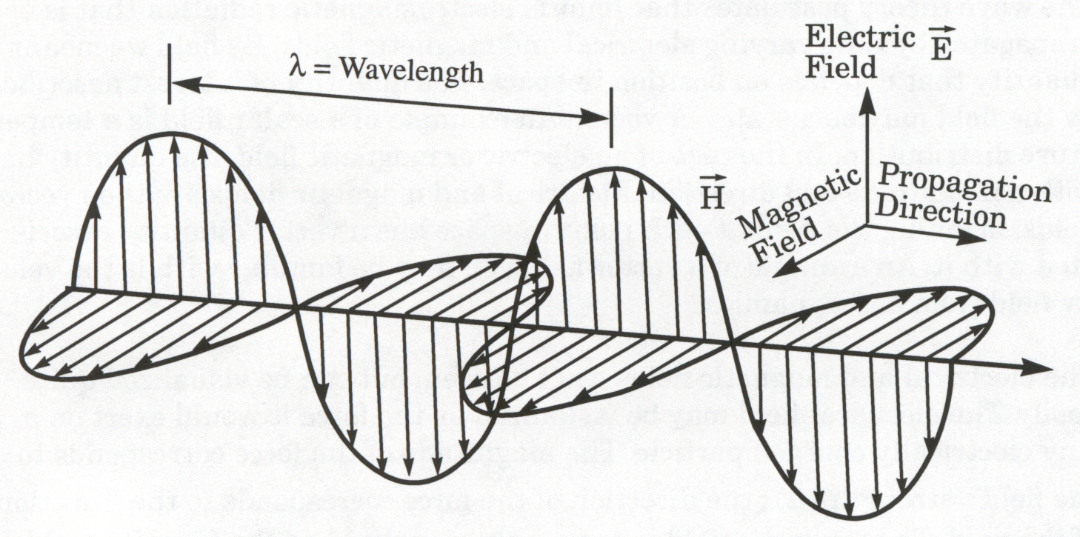

**Figure 1 - The Electromagnetic Spectrum**

**19.2 The Electromagnetic Spectrum**

The electromagnetic spectrum, as illustrated in figure 2, was devised by scientists during the 19th century. The combination of radiation waves of all different wavelengths in the universe is called electromagnetic radiation, and the whole array of different kinds of radiation, arranged according to wavelength or frequency, is called the electromagnetic spectrum. Scientists and engineers find this concept a very useful method of classifying the electromagnetic radiation that occurs in our universe by the physical properties of the radiation, typically by wavelength and frequency, but also by energy, and temperature. Many of the systems used onboard aircraft and spacecraft operate within various regions of the electromagnetic spectrum. Some common examples would include radar, electro-optical sensors, radios, data links, electronic warfare, navigation systems, and many others.

Figure 2 compares the size of the wavelength of an electromagnetic wave to some common references found in the everyday world around us, and provides examples of common sources and uses of various frequencies and wavelengths of electromagnetic radiation and where they occur in the electromagnetic spectrum.

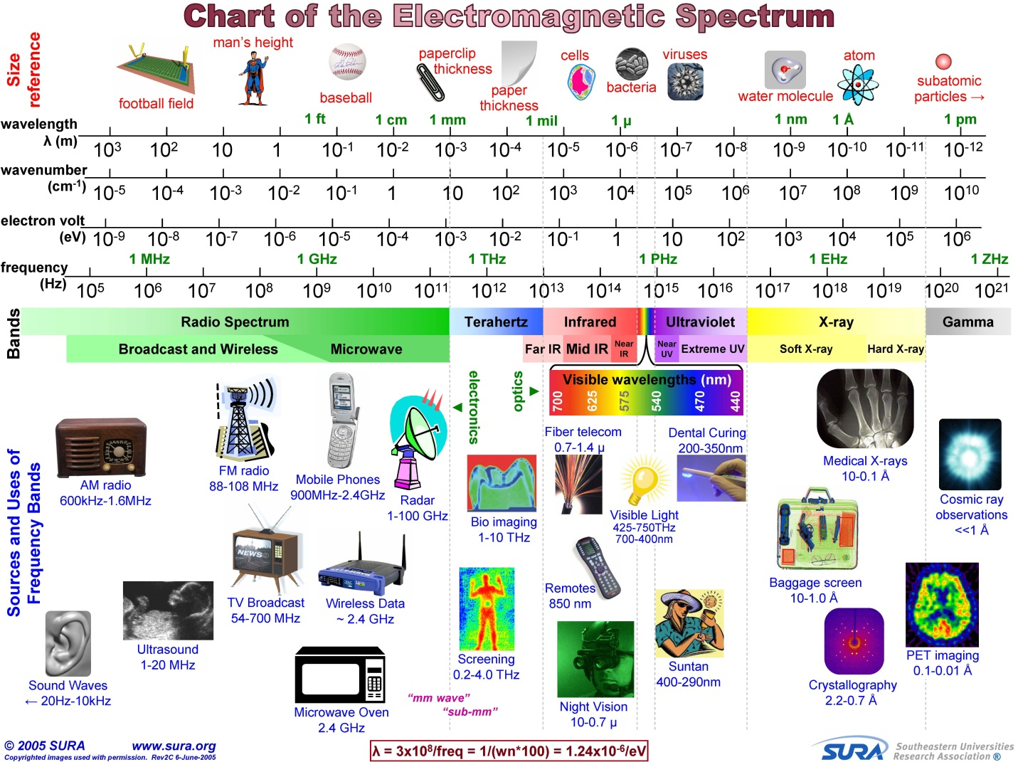

**Figure 2 - The Electromagnetic Spectrum**

**19.3 Radio Frequency Electromagnetic Radiation**

One of the most heavily used regions of the electromagnetic spectrum is the radio frequency or RF region (called the RF spectrum) from approximately 3 kilohertz out to approximately 300 gigahertz. The RF Spectrum covers a wide array of telecommunications devices including radios, television, satellite communications, data links, radio-navigation aids, and radar. The RF Spectrum is subdivided into frequency bands as shown in Table 1.

|  |  |  |
| --- | --- | --- |
| **Band Designation** | **Label** | **Frequency Spread** |
| Extremely Low Frequency | ELF | 3 - 30 Hz |
| Super Low Frequency | SLF | 30 - 300 Hz |
| Ultra Low (Voice) Frequency | ULF or VF | 300 Hz - 3 KHz |
| Very Low Frequency | VLF | 3 - 30 KHz |
| Low Frequency | LF | 30 - 300 KHz |
| Medium Frequency | MF | 300 KHz - 3 MHz |
| High Frequency | HF | 3 - 30 MHz |
| Very High Frequency | VHF | 30 - 300 MHz |
| Ultra High Frequency | UHF | 300 MHz - 3 GHz |
| Super High Frequency | SHF | 3 - 30 GHz |
| Extremely High Frequency | EHF | 30 - 300 GHz |

**Table 1 - Radio Frequency Band Designations**

Depending on the type of RF system, additional subdivisions of the bands also exist. For example, when working with radar systems, the bands shown in table 2 are appropriate to use.

|  |  |  |  |  |
| --- | --- | --- | --- | --- |
| **IEEE US**  **(Old RADAR Designation)** | **Origin** | **Frequency Range** | **Wavelength** | **NATO, US ECM**  **(New RADAR Designation)** |
| **W** | **W follows V in the alphabet** | **75-111 GHz** | **400 mm-270 mm** | **M**  **(60-100 GHz)** |
| **V** | **Very Short** | **40-75 GHz** | **700 mm – 400 mm** | **L**  **(40-60 GHz)** |
| **KA** | **Kurtz (above)** | **26-40 GHz** | **1.1 cm -.7 cm** | **K**  **(20-40 GHz)** |
| **K** | **Kurtz (which is German for short)** | **18-26 GHz** | **1.6 cm – 1.1 cm** | **J**  **(10-20 GHz)** |
| **KU** | **Kurtz (under)** | **12.4-18 GHz** | **2.5 cm – 1.6 cm** |
| **X** | **Used in WWII for fire control as an “X” for crosshairs** | **8-12.4 GHz** | **3.7 cm -2.5 cm** | **I**  **(8-10 GHz)** |
| **C** | **Compromise between S and X** | **4-8 GHz** | **7.5 cm -3.7 cm** | **H**  **(6-8 GHz)**  **G**  **(4-6 GHz)** |
| **S** | **Short Wave** | **2-4 GHz** | **15 cm – 7.5 cm** | **F**  **(3-4 GHz)**  **E**  **(2-3 GHz)** |
| **L** | **Long Wave** | **1-2 GHz** | **30 cm – 15 cm** | **D**  **(1-2 GHz)** |
| **UHF** |  | **.3-1 GHz** | **<1 m – 30 cm** | **C**  **(.5-1 GHz)** |

**Table 2 - Radar Frequency Band Designations**

Electromagnetic wave propagation does not stop at national boundaries. The use of radio frequency bands of the electromagnetic spectrum is regulated by governments in most countries in a spectrum management process known as frequency allocation or spectrum allocation. Citing technical and economic reasons, governments have sought to harmonize the allocation of RF bands and their standardization. A number of forums and standards bodies work on standards for frequency allocation, including the International Telecommunication Union (ITU). The ITU is the United Nations specialized agency for information and communication technologies – ICTs. According to their mission, *the ITU allocates global radio spectrum and satellite orbits, develops the technical standards that ensure networks and technologies seamlessly interconnect, and strives to improve access to ICTs to underserved communities worldwide. ITU is committed to connecting the entire world's people – wherever they live and whatever their means. They protect and support everyone's fundamental right to communicate*.

Figure 3 illustrates United States frequency allocations for the RF spectrum as of 2011. This chart may be downloaded in high resolution and/or purchased as a wall size poster at this U. S. government website: <http://bookstore.gpo.gov/products/sku/003-000-00694-8>. It should be apparent from the chart that there are numerous users and that spectrum allocation, while easy to define, is very complicated to implement and regulate.

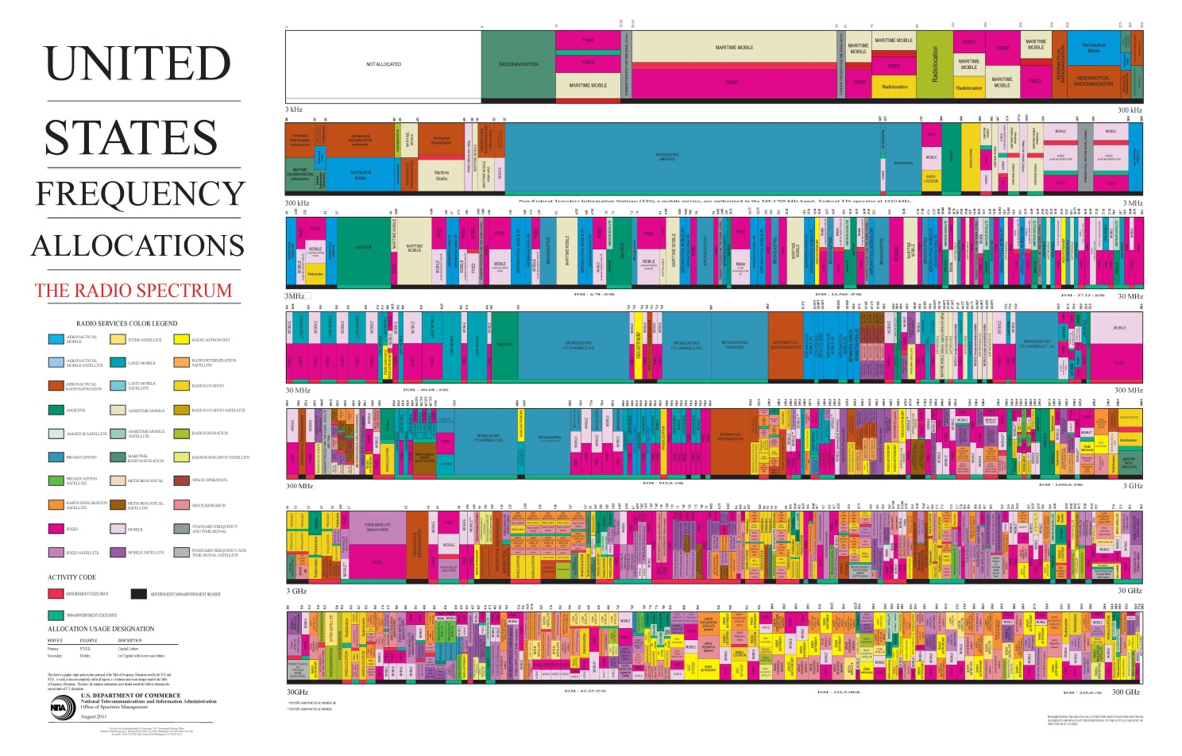

**Figure 3 - U.S. Radio Frequency Allocations (2011)**

**19.4 Optical Frequency Electromagnetic Radiation**

Optical frequency electromagnetic radiation includes ultraviolet (UV), visible, and infrared (IR) light ranging from about 0.01 microns out to about 1000 microns in wavelength. Combined, the UV, visible, and IR radiation make up the optical spectrum as shown in figure 4.

🡨Optical Spectrum🡪

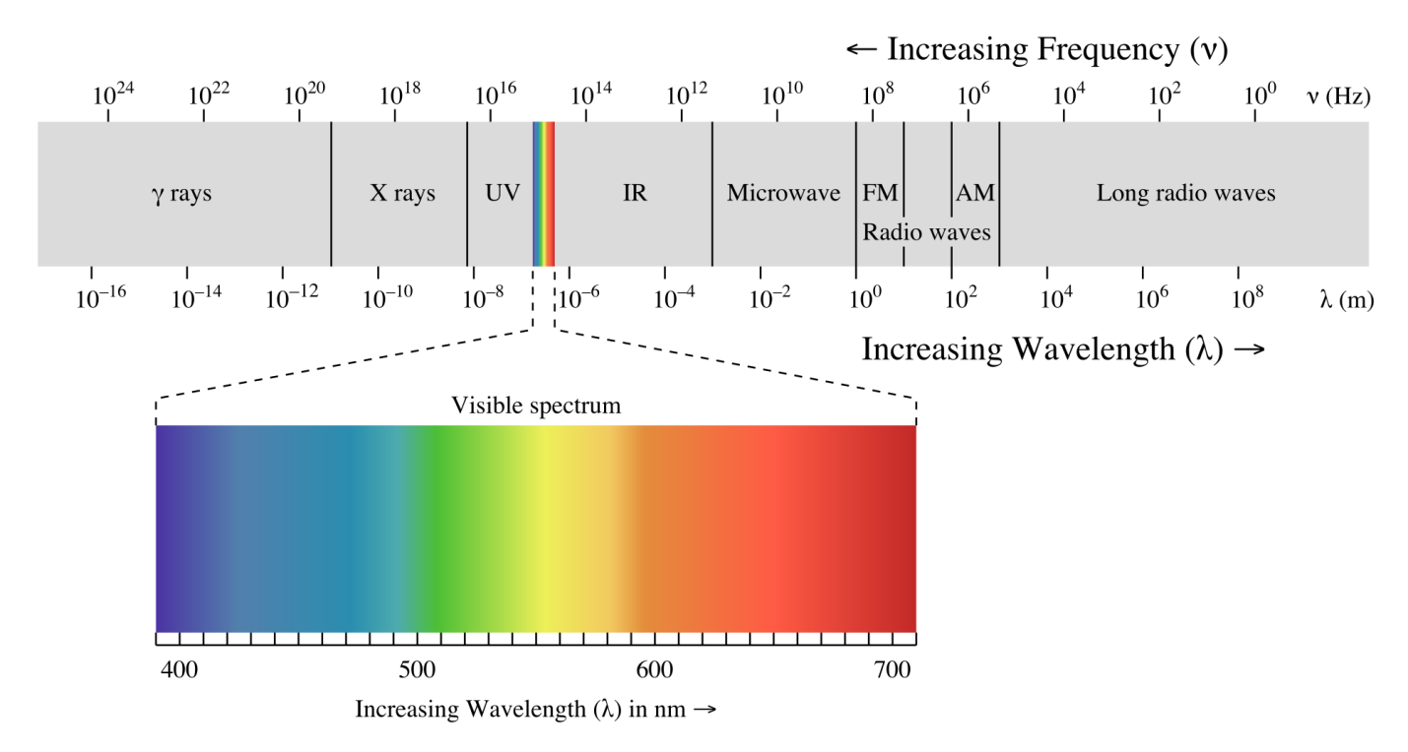

**Figure 4 - The Optical Spectrum and the Visible Spectrum**

Just like the RF spectrum can be subdivided into various special bands, the optical spectrum is divided into bands as shown in table 3. Sometimes the nomenclature and boundaries of these bands is author and text dependent. The visible, near IR (NIR), mid wave IR (MWIR), and long wave IR (LWIR) are the most commonly used bands used by airborne electro-optical sensor systems. However, all these bands can be useful depending on the specific mission and operational requirements.

The most familiar example of electromagnetic radiation is visible light or the light that our human eyes can see. Different colors of visible light have slightly different wavelengths, ranging from the violet (~400 nanometers or 0.4 microns) at the shorter wavelengths to the red (~700 nanometers or 0.7 microns) at the longer wavelengths. Many visible light sensor systems are employed on aircraft and spacecraft. Visible light sensors provide very useful and highly recognizable images, but do not work well in poor visibility conditions. Nor do they work well at night without some sort of artificial illumination or image intensification.

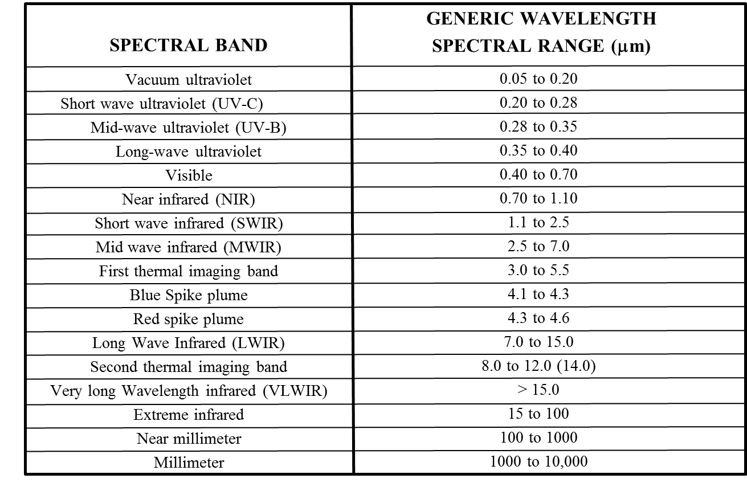

**Table 3 - Optical Spectrum Bands**

Infrared radiation refers to that region of the optical spectrum ranging from about 0.7 microns out to about 1000 microns. This region is referred to as the infrared spectrum. Infrared radiation is popularly known as "heat or thermal radiation", but light and electromagnetic waves of any frequency will heat surfaces that absorb them. Infrared light from the Sun only accounts for about 49% of the heating of the Earth, with the rest being caused by visible light that is absorbed then re-radiated at longer wavelengths. Objects at room temperature will emit radiation mostly concentrated in the 8 to 25 µm region.

Infrared sensors are extremely useful in a number of remote sensing applications to include civil and military. However, at wavelengths beyond about 14 microns, infrared radiation is not useful for most airborne remote sensing applications due to severe attenuation by the earth’s atmosphere. This is especially true in hot humid climates, where atmospheric attenuation of infrared radiation is extreme.

**19.5 Atmospheric Transmission Windows**

Our earth’s atmosphere is both extremely helpful when it comes to life on our planet, but also is sometimes harmful when it comes to remote sensing applications. Our sun is the major source of natural energy for our world, across the entire electromagnetic spectrum, and its electromagnetic radiation bombards our atmosphere constantly. Fortunately, the earth's atmosphere protects us from exposure to a range of higher energy waves that can be harmful to humans and other life forms on our planet. Gamma rays, x-rays, and some ultraviolet waves are "ionizing" radiation, meaning these waves have such a high energy that they can knock electrons out of atoms. Exposure to these high-energy waves can alter atoms and molecules and cause damage to cells in organic matter. These changes to cells can sometimes be helpful, as when radiation is used to kill cancer cells, and other times not, as when we get sunburned, or worse. Figure 5 show the relationship between atmospheric opacity and wavelength of the electromagnetic radiation.

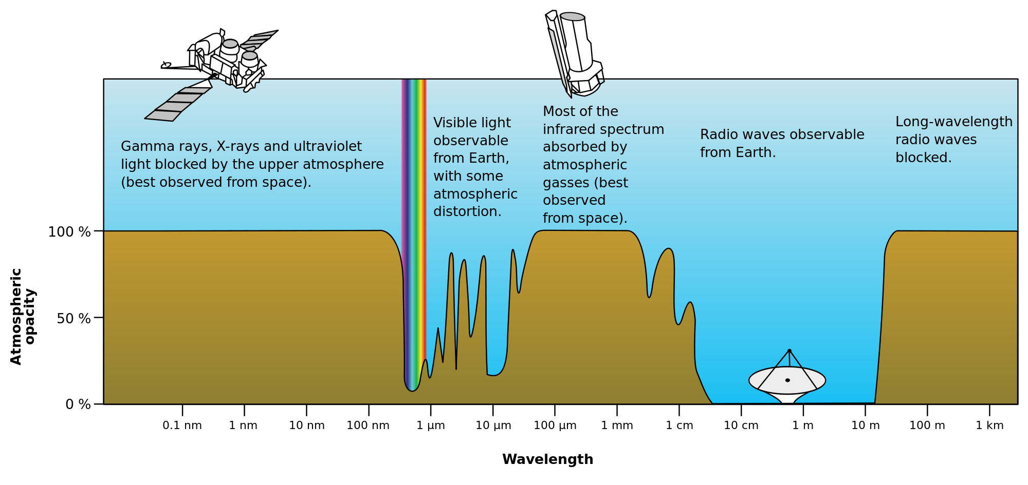

**Figure 5 - Atmospheric Opacity vs. Wavelength**

Electromagnetic radiation is transmitted through, reflected/refracted by, or absorbed by our atmosphere. Suspended particles such as dust and raindrops can reflect and refract radiation. Several common gases in the Earth's atmosphere absorb radiation at certain wavelengths, among the most important being water vapor, carbon dioxide, and ozone. Some radiation, visible light and portions of the infrared, can mostly pass through (transmit through) the earth’s atmosphere. These regions of the spectrum where certain wavelengths of electromagnetic radiation can pass through the atmosphere with little to no attenuation are referred to as “atmospheric windows” or “transmission windows”. Without these atmospheric windows, infrared remote sensing from significant standoff distances would be impossible due to extreme atmospheric attenuation.

Figure 6 shows the relationship between atmospheric transmission of electromagnetic radiation through the atmosphere and radiation wavelength for the visible and infrared regions of the electromagnetic spectrum from 0 to 14 microns. The atmospheric windows at 3 to 5 microns and 8 to 14 microns are indicated by the arrows. There are other windows that can be seen in the visible and shorter wave infrared as well. The bottom scale of figure 6 also indicates that the H2O, CO2, and O3 molecules are the primary infrared radiation absorbers.

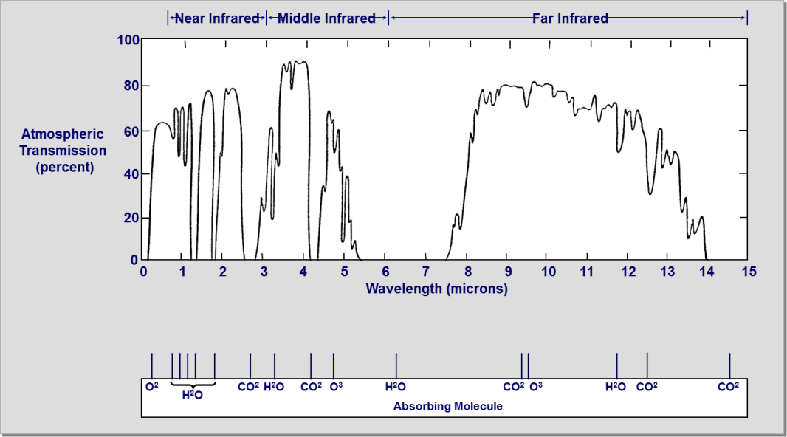

**Figure 6 - Infrared Atmospheric Transmission Windows at 3-5 and 8-14 microns**

It is important to consider what wavelengths these atmospheric windows occur at when choosing a remote sensor system for a particular mission. For example, there are some wavelengths where the atmosphere is almost completely opaque to electromagnetic radiation. It is significant to note that some microwaves pass very well through clouds as well as through the atmosphere, which make them the best wavelength for transmitting satellite communication signals.